

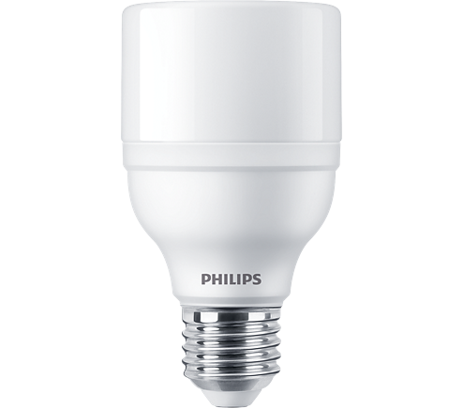

LED BULB

* 20W-145(145W GLS, 35W CFL)W
* E27
* Cool Daylight

**Rs 345.00**